Barbershop Tags for Everyone – by Paul C. Olguin
Find these tags and many more for FREE at www.barbershoptags.com

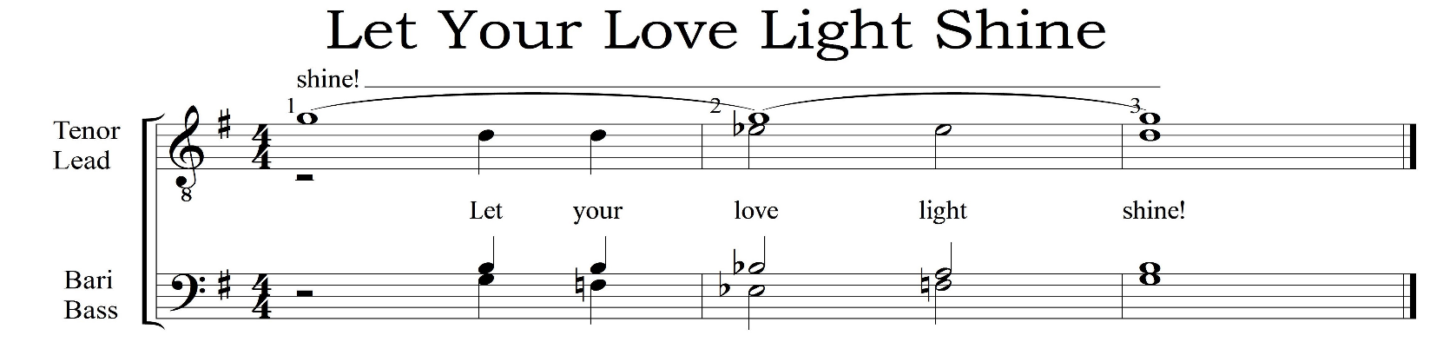

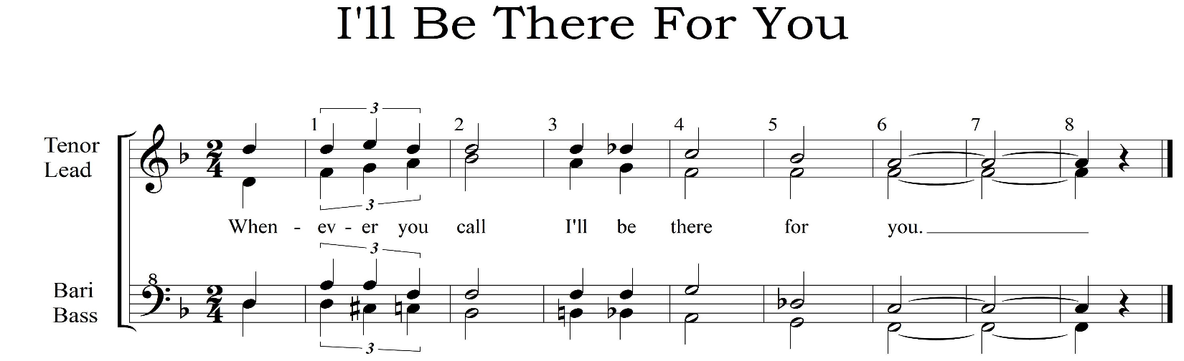

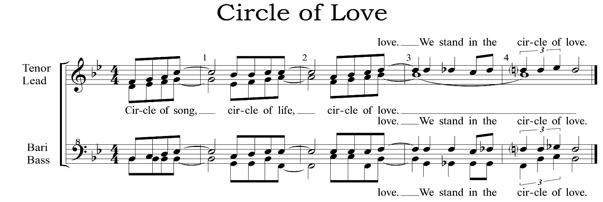

©Copyright 2014 Paul Carey Olguin
CC-BY-SA 4.0 International
You are free to share and modify.
Just include credit and keep this license with the new version.
